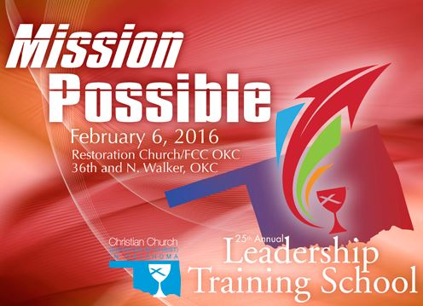

**Mission Possible** is the theme for the **Regional Church’s 2016 Annual Leadership Training School** which will take place on **Saturday, Feb. 6th** at **Restoration Church (formerly First Christian Church) of Oklahoma City.**  Registration opens at 8:15 a.m. with worship beginning at 8:45 a.m., and Leadership Training School ending at 12:30 p.m.

There will be an opportunity to take three 45 minute classes during the day. A wide variety of classes will be offered in three tracks: Mission, Spiritual Growth, and Practical Ministry. Anyone in a congregation is welcome to attend; you can take all your classes in one track, or you can pick and choose the classes you would like to attend.

Our keynote speaker for the day is Vy Nguyen, Executive Director of Week of Compassion. Vy holds a Master of Divinity from the Divinity School at the University of Chicago, and earned his B.A. in religious studies with a minor in environmental sciences from Texas Christian University. He joined Week of Compassion after serving more than 5 years with Church World Service for the Southwest Regional Office where he worked with congregations and donors to increase their fundraising portfolio. Prior to his work with Church World Service, Vy worked with the Lutheran Volunteer Corps office in Berkeley, CA where he strengthened relationships between volunteers, congregations, and non-profit agencies. Vy and his wife, Linh Bui, live in Oakland, CA.

LTS registration is $60 for congregations or $8 for individuals. There is no registration fee for children or youth.

Nursery and childcare will be provided for infants through grade 5. Youth, grades 6-12, are invited to attend the regular classes.

For more information, visit the Regional Church website: [www.okdisciples.org](http://www.okdisciples.org)/lts-2016 or call 405.528. 3577.



Come join church members and leaders from around Oklahoma as we gather together for 2016 Leadership Training School. You won’t want to miss a variety of workshops planned to assist you in your faith journey.

Vy Nguyen, the Executive Director of Week of Compassion will give a keynote address during the opening worship which begins at 8:45 a.m.

This year you can view all the registration materials online, and you’ll have an opportunity to register for the three classes that interest you the most.

Cost is $60/congregation or $8/individual.

Nursery and childcare will be provided for infants through 5th grade. youth, grades 6-12 , are invited to attend the regular classes.

More information is available at [www.okdisciples.org](http://www.okdisciples.org)/lts-2016 or by calling 405.528.3557.



**Mission – Spiritual Growth – Practical Ministry**

***Plus Several Hands-On Mission Opportunities***

***Mission Possible!***

**2016 Leadership Training School**

**Restoration Church (formerly First Christian Church)**

**Oklahoma City**

**8:15 a.m. – 12:30 p.m.**

**Keynote Address: Vy Nguyen**

**Register for the three classes you like best online at** [**www.okdisciples.org**](http://www.okdisciples.org)**.**

**Cost: $60 per congregation or $8 per individual**

**(No registration fee for children or youth)**

**Childcare for infants through grade 5. Youth, grades 6-12, encouraged to attend a session.**